Preparation for using Zhenhai scripts
Purpose:
1. To create a folder for personal use under the path of /export/home
2. To link the folder where Zhenhai's codes are saved to individual apollo user account

Steps:
- Apply for an apollo account from Andy Cobaugh (phalenor@bx.psu.edu, Wartik Building)
- In Mac computer, initiate Terminal from /Applications/Utilities/Terminal
- Log into your apollo account
- Set up the path for linking your account folder and the folder where Zhenhai saves his scripts. This only needs to be done only once just before using the scripts.
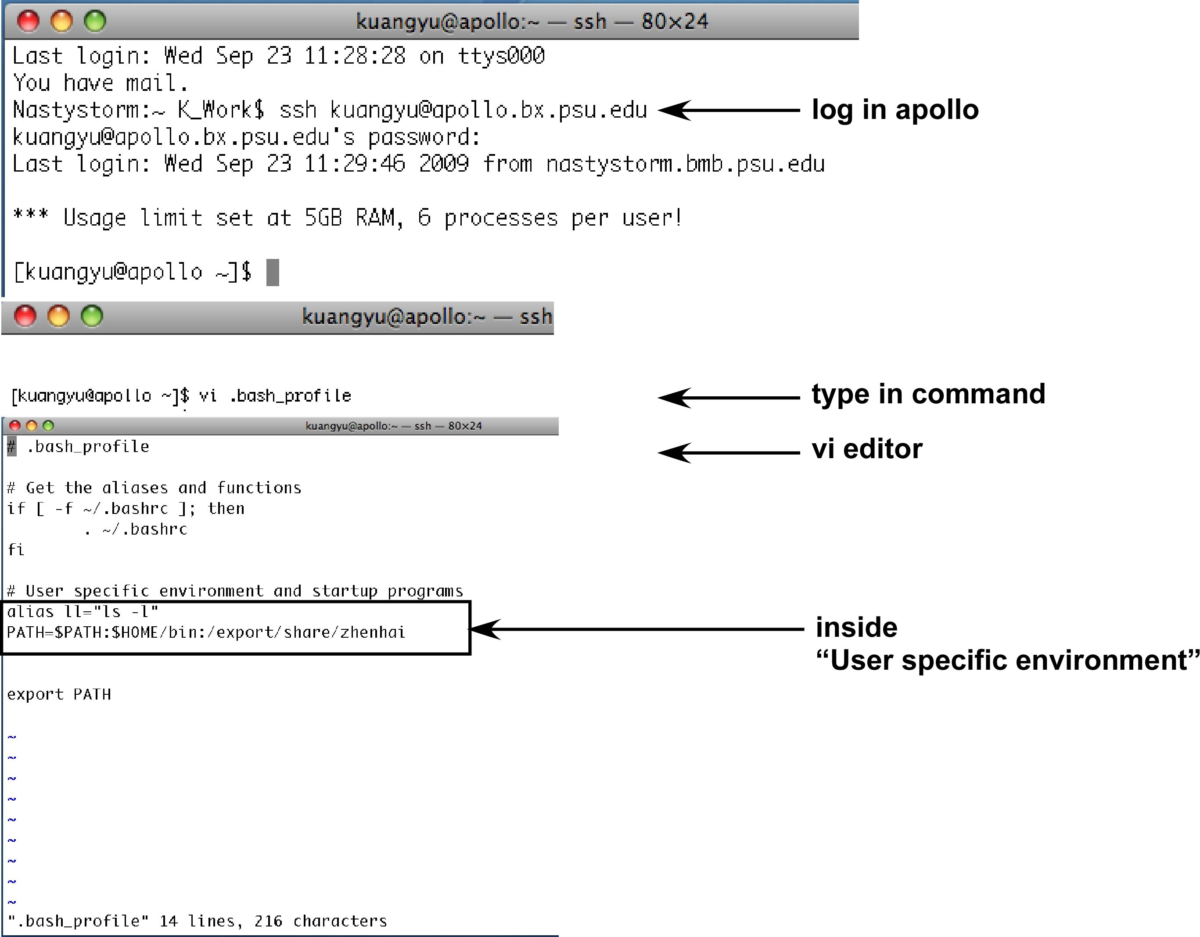
vi .bash_profile
i (press i in order to edit in vi) (Reference as how to use vi editor in Linux: http://www.eng.hawaii.edu/Tutor/vi.html#quit)
PATH=$PATH:/export/share/zhenhai
press escape (in order to go to command line)
:wq (save the change and leave the vi editor)
- test -f /afs/bx.psu.edu/service/etc/set-path.sh && . /afs/bx.psu.edu/service/etc/set-path.sh (for using pagscr -> similar function as screen in linux)
- source .bash_profile (in order to let $PATH recognise the changes in .bash_profile
echo $PATH (to verify that the path has been linked)

ChIP-seq Data analysis
Workflow of ChIP-seq data analysis
- Separate sequence tags by barcode
- Map tags back to the reference sequence by SHRiMP software
- Tag mapping relative to the reference genome
(Reference as how to use Linux command: http://linuxreviews.org/beginner/)

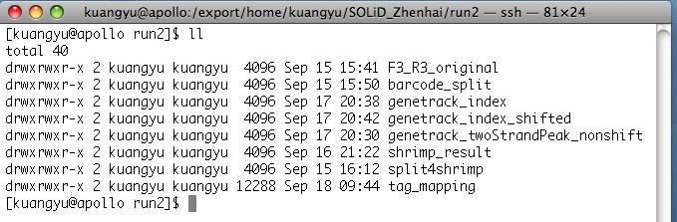

Figure: Folder organisation by using Zhenhai's script
- F3_R3_original: All the raw sequencing data and the barcode information (barcodes.config) is stored here.
- barcode_split: Where the output of barcode separation is stored
- split4shrimp and shrimp_result: Tag mapping to the reference sequence has two different folders: "split4shrimp" contains all smaller files for SHRiMP, and "shrimp_result" has the output result from SHRiMP.
- genetrack_index: Tags containing its coordinate sequencing information are stored here.
- genetrack_twoStrandPeak_nonshift: Files containing nucleosome prediction plus nucleosome peak height value generated through LionDB are stored here.
- genetrack_index_shifted: Tags whose positions have been shifted to the dyad location are stored here.
- tag_mapping: For each sample, all the tags are redistributed relative to the coordinate information, such as TSS or TTS, and stored here.

Step 1: Barcode separation
Purpose: In order to increase the number of samples of sequencing, we add barcoded apator to different ChIP samples. After sequencing, we then need to separate the raw sequence tags into different ChIP samples by linking the sequence tags with its related barcodes, and then separate the tags with different barcodes.

SOLiD system:
A) Create a folder (called F3_R3_original in this case) to store your raw ChIP-seq data
(Note) If you have multiple ChIP-seq data sets, you can create a master folder which contains sub-folders that store the raw ChIP-seq data with its related barcodes.config file.

B) Generate barcodes.config file and store it in the same folder as where you store the raw ChIP-seq data. The barcode.config is requisites for running the script, and its format should look like the following figure.
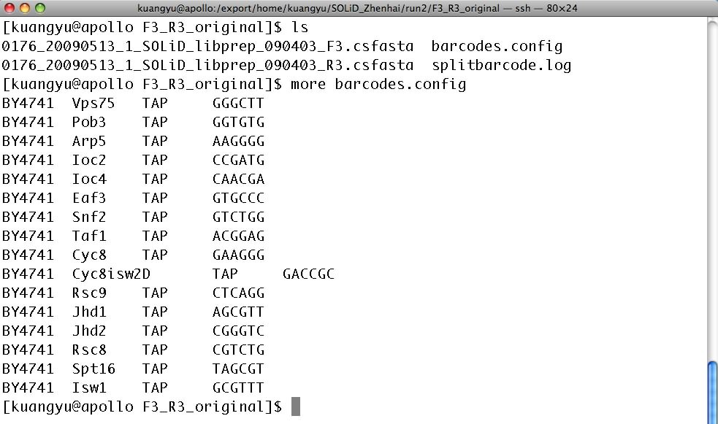
(Note) In SOLiD sequencer, R3 files contain barcode sequence while F3 files contain the sequence for the ChIP-DNA.
C) Run script for barcode separation under the master folder where contains the subfolder of the raw ChIP-seq data and barcode.config file. This script will create a folder called barcode_split, and store all the barcode separated files in that folder.
(Note) If you have multiple ChIP-seq data sets, you should run the script in the master folder which contains sub-folders that store the raw ChIP-seq data with its related barcodes.config file.

standAlonePairBarcodeSplit.py 6

(Note) 6 means allowing 6 barcode nucleotides.

Solexa Illumina system

Step 2: Tag mapping to the reference sequence by SHRiMP
Purpose: Assign the sequence information, such as which chromosome and which location in that chromosome, to each tag by SHRiMP software. Since each sequence file is too big for SHRiMP to handle, we need to split each sequence file into smaller files first. Once these smaller files have done assigning sequence information, we need to combine the related ones back to a complete sequence file.

SOLiD system:
A) Run script for splitting each sequence file into smaller files. This script should be run under the barcode_split folder, and it will create two folders: split4shrimp and shrimp_result. The split4shrimp folder contains all smaller files for SHRiMP and the commands for tag_mapping by SHRiMP. The shrimp_result folder contains all the tag mapping results for those smaller files.
cd barcode_split
split4shirimp.py 500000
(Note) 500000 means how much data each smaller file contains.
cd ../split4shrimp
chmod +x cmd*
nohup cmd* &
B) Combine related smaller files into one complete sequence file. The script should be run in the shrimp_result folder, and it will create a folder called genetrack_index and store all the complete sequence files in that folder.
cd ../shrimp_result
shrimp_merge_and_retrieve_v2.py -suffix .txt -m 6 -l 35
(Note) There are three parameters needed to be set.
–suffix: means what suffix do those smaller files need to be put back into one complete sequence file.
–m: means how many mismatches are allowed. Here, 6 mismatches are allowed.
–l: means the length of the sequence. Here, it means 35bp is the total length for each tag.

Solexa Illumina system
A)

B) Convert *_extended.txt to LionDB readable format
cd /export/home/megha/Solexa_run1
eland_extended_genetrack_nonshift.py –s .txt –l 70

Step 3: Shift tags to the dyad location.
A) Calculate the distance for tag shiftting.
i) Apply an account for LionDB from Istvan Albert (iua1@psu.edu,Wartik Building)
ii) download all the complete sequence files (located at genetrack_index folder), and upload them to the LionDB
iii) generate peak-height prediction from LionDB
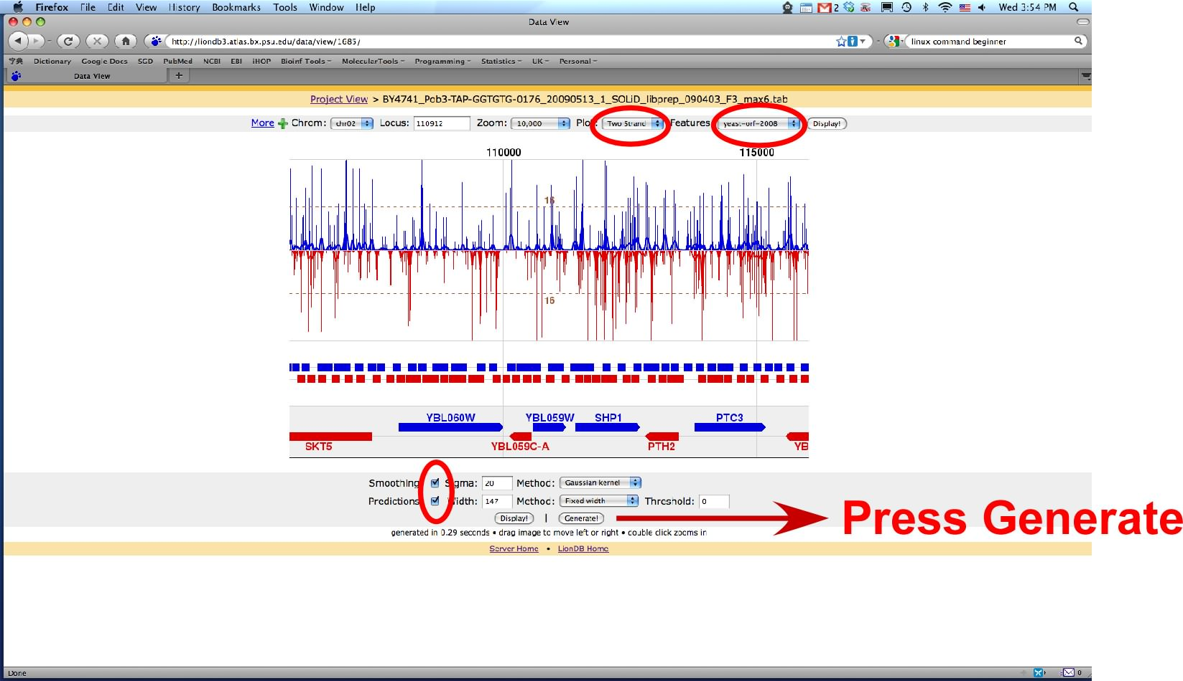
iv) download Peaks-sigma files from LionDB and upload them to apollo server under the folder named "genetrack_twoStrandPeak_nonshift".
(Note) Istvan has provided a script for the same function
1. export PYTHONPATH=/afs/bx.psu.edu/depot/data/pugh_lab/local/src/gc:$PYTHONPATH
2. python -m genetrack.scripts.hdf_loader
3. python -m genetrack.scripts.peakpred
4. python -m genetrack.scripts.hdf_loader -i genetrack_index.tab –u
5. python -m genetrack.scripts.peakpred -i genetrack_index.tab -o output.txt --exclusion 147 --sigma 5 --strand two

v) run script to calculate the distance for shift. It should be run under the "genetrack_twoStrandPeak_nonshift" folder, and it will generate a "shift.config" file in the "genetrack_index" folder. The "shift.config" contains how much nucleotide shift for each sample, and is requisites for the following script.

cd ../genetrack_twoStrandPeak_nonshift
forward_reverse_dyad_dist_v2.py

B) Shift the tag position. The script will create a folder called "genetrack_index_shifted", and shift the tag position in all complete sequence files in "genetrack_index" folder and store the shifted files in the "genetrack_index_shifted" folder.

cd ../genetrack_index
shift_and_consolidate_tags.py

Step 4: Map tags relative to the coordiates (such as TSS)
Purpose: This step will generate a matrix which contains gene id and its related tag count for every individual location relative to the cooridate, such as TSS or TTS.

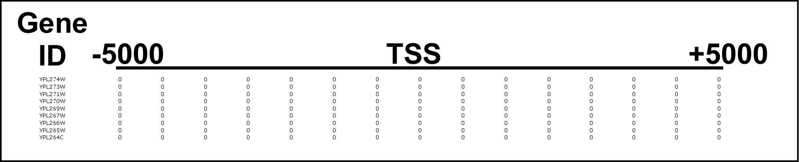

The script has to be run under the "genetrack_index_shifted" folder. It will create a tag_mapping folder automatically, and the output files will be stored in that folder.
cd genetrack_index_shifted
tag_mapping_v4.py -suffix .tab -l 5000
(Note) There are two parameters needed to be set.
–suffix: means what suffix do those smaller files need to be put back into one complete sequence file.
–l: means the length of the location upstream and downstream relative to the cooridate. Here, 5000 means 5,000bp upstream and downstream relative to the cooridate, such as TSS. So, totally, it will has 100,000bp information for each gene.

Step 5 (Optional):
Purpose: This step will generate a matrix which contains total tag counts for all the genes in every individual location relative to the cooridate, such as TSS or TTS, for all the samples.

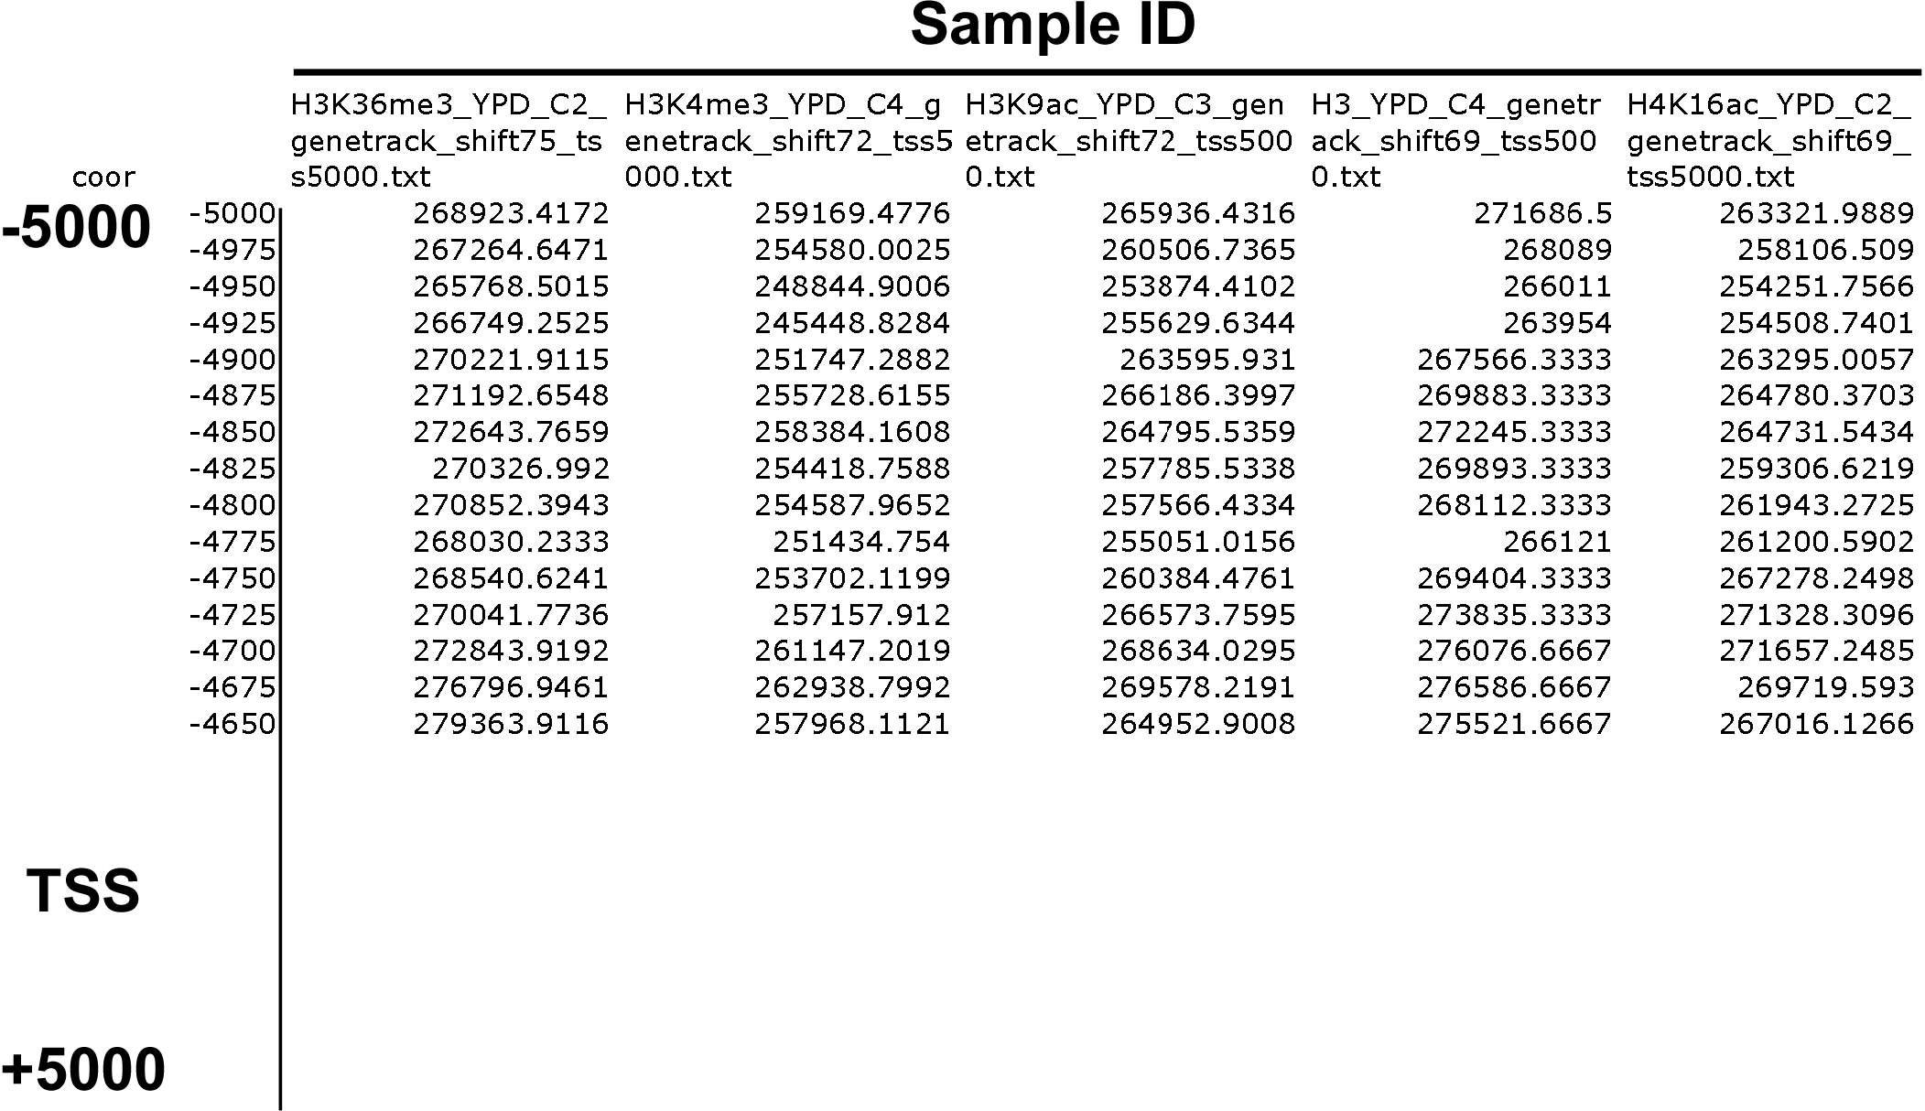

This script has to be run in the same folder where the tag_mapping files store. It can be the same folder which is generated by running tag_mapping_v4.py script, or we can create a new folder, and copy whichever tag_mapping file of interest.
cd tag_mapping
compose_multi_vector_files.py -s .txt -bi 5000

After composing the matrix which contains total tag counts for all the genes in every individual location relative to the cooridate, such as TSS or TTS, for all the samples. We need to smooth the tag counts for plotting purpose. The following script needs to be run in the same folder where the vector files generated from previous script stores.

bin_smooth_single_file.py -i tss_5000.tab -b 5 -s 2

(Note) There are 3 parameters needed to be set.
–i: means which input file you would like to apply for bin size and smoothing.
–b: means bin size.
–s: means smooth number. Here 2 actually means using 3 smooth

Step 6 (Optional):
Purpose: This step will create bin and smooth for individual sample generated by tag_mapping_v4.py

This script has to be run in the same folder where the tag_mapping files store. It can be the same folder which is generated by running tag_mapping_v4.py script, or we can create a new folder, and copy whichever tag_mapping file of interest.

mkdir multi_vector
cd multi_vector
vector_pickle_region.py -suffix .txt -bi 5000 -u -1000 -d 1000 -b 25 -s 2
(Note) There are 6 parameters needed to be set.
–suffix: means what suffix do those smaller files need to be put back into one complete sequence file.
–bi: means the length of the location upstream and downstream relative to the cooridate. Here, 5000 means 5,000bp upstream and downstream relative to the cooridate, such as TSS.
–u: means how much upstream you would like to choose. Here, -1000 means 1000bp upstream of TSS.
–d: means how much downstream you would like to choose.
–b: means bin size.
–s: means smooth number. Here 2 actually means using 3 smooth

